Batch: C3 Roll No.: 16010123217

Experiment No. 08

Grade: AA / AB / BB / BC / CC / CD /DD

Signature of the Staff In-charge with date

Title: Study, Implementation, and Analysis of Graph Coloring Problem.

Objective: To learn the Backtracking strategy of problem solving for Graph Coloring Problem.

CO to be achieved:
CO 2 | Analyze and solve problems for divide and conquer strategy, greedy method, dynamic programming approach and backtracking and branch & bound policies.

Books/ Journals/ Websites referred:
- Ellis horowitz, Sarataj Sahni, S.Rajsekaran,” Fundamentals of computer algorithm”, University Press
- T.H.Cormen ,C.E.Leiserson,R.L.Rivest and C.Stein,” Introduction to algortihtms”,2nd Edition ,MIT press/McGraw Hill,2001

Pre Lab/ Prior Concepts:
Data structures, Concepts of algorithm analysis

Historical Profile:The Graph Coloring Problem is a classical problem in graph theory and combinatorics with origins rooted in practical applications and mathematical curiosity. It has a rich history, spanning over two centuries, and remains a vibrant area of research due to its theoretical significance and real-world applications.

Origins and Early History
Map Coloring and the Four Color Theorem (1852):The problem of graph coloring originated from an attempt to color regions on maps so that no two adjacent regions share the same color. In 1852, Francis Guthrie, a British mathematician, conjectured the Four Color Theorem, stating that four colors are sufficient to color any map in a plane.
Graph Representation of Maps:In 1879, Arthur Cayley formulated the map coloring problem in terms of graph theory, representing regions of a map as vertices and adjacency as edges.
New Concepts to be learned:
Application of algorithmic design strategy to any problem, Backtracking method of problem solving Vs other methods of problem solving problem sum of subset and its applications.

Algorithm:

Backtracking Algorithm
The backtracking approach finds the optimal solution by trying all possible color assignments.
Steps:
- Try assigning each vertex a color from 1 to k, where k is the number of colors.
- Backtrack if an assignment leads to a conflict (two adjacent vertices having the same color).
- Continue until all vertices are colored or all possibilities are exhausted.

Implementation(Code):

#include <iostream>
#include <vector>
using namespace std;

int solutionCount = 0;

bool isSafe(int vertex, vector<vector<int>>& graph, vector<int>& color, int c) {
for (int i = 0; i < graph.size(); i++) {
if (graph[vertex][i] && color[i] == c) {
return false;
}
}
return true;
}

void graphColoringUtil(vector<vector<int>>& graph, int m, vector<int>& color, int vertex) {
if (vertex == graph.size()) {

solutionCount++;
cout << "Solution " << solutionCount << ": ";
for (int c : color) {
cout << c << " ";
}
cout << endl;
return;
}

for (int c = 1; c <= m; c++) {
if (isSafe(vertex, graph, color, c)) {
color[vertex] = c;
graphColoringUtil(graph, m, color, vertex + 1);
color[vertex] = 0;
}
}
}

void graphColoring(vector<vector<int>>& graph, int m) {
vector<int> color(graph.size(), 0);
graphColoringUtil(graph, m, color, 0);

if (solutionCount == 0) {
cout << "No solution exists." << endl;
} else {
cout << "Total number of valid colorings: " << solutionCount << endl;
}
}

int main() {
vector<vector<int>> graph = {
{0, 1, 1},
{1, 0, 1},
{1, 1, 0}
};

int m = 3;

graphColoring(graph, m);

return 0;
}

Output:

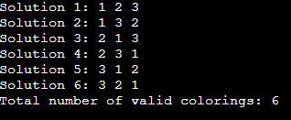

Analysis and Example Graph Coloring Problem along with state space tree:

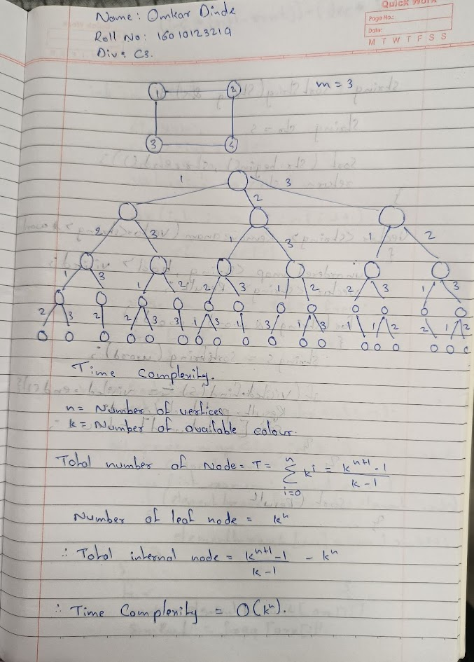
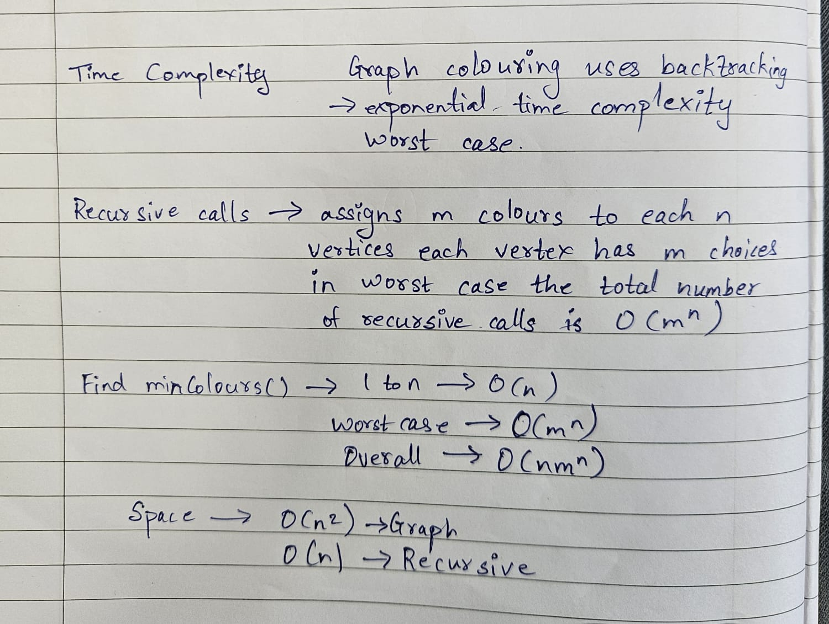

Conclusion:

The Graph Coloring Problem, when solved using the Backtracking strategy, showcases the power of recursive decision-making and backtracking when navigating large solution spaces. While not optimal for large graphs, it provides a foundation for understanding constraint satisfaction problems and the trade-offs between brute-force search and heuristic or greedy strategies.

